- Abiotic and biotic factors
- The photograph below shows a Great Crested Newt (Triturus cristalus). It is found in large ponds with lots of plants but no fish. Triturus cristalus feeds off invertebrates and tadpoles mainly. It is active at night and spends the day at the bottom of the pond or in vegetation. Predators include foxes, rats, cats and badgers.
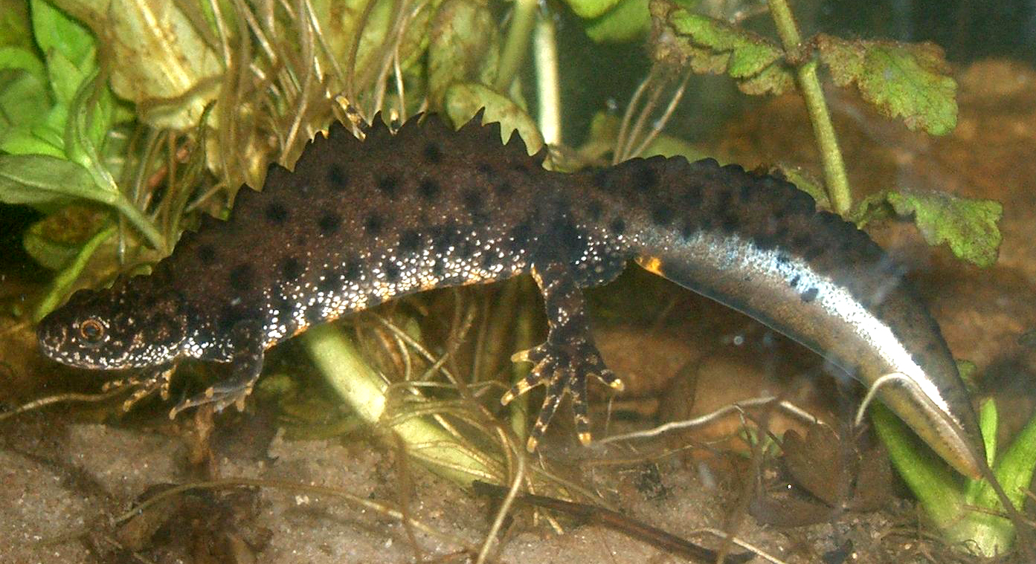
- An ideal habitat for a population of Great Crested Newts is where many ponds are found close to each other, separated by grassland. Suggest the benefits of having several ponds close to each other. (2)
Two of:
Ability to find a mate to reproduce
If one pond becomes polluted or unsuitable there are options to relocate
Less competition for space, food, mates

- Describe 3 biotic factors which may affect a population of Great Crested Newts. (3)
Availability of food
New predators arriving
New pathogens

- Dunsbury Park is home to a small herd of red deer which feed on grass, tree bark and the new shoots of plants. A rare type of violet plant is found to occur on the land in shaded woodland. Wolves roamed wild in the area and were predators of deer. The landowner wanted to preserve the herd of deer and so began to shoot the wolves when they came onto his land. By the end of 2013, all the wolves were killed.

Number of organisms | May 2010 | Nov 2010 | May 2011 | Nov 2011 | May 2012 | Nov 2012 | May 2013 | Nov 2013 | May 2014
Deer | 2302 | 2130 | 2370 | 2267 | 2705 | 2690 | 2752 | 2712 | 1946
Violet plants | 24 | 21 | 23 | 16 | 5 | 2 | 4 | 1 | 0

- Use the graph paper and a suitable method to display the data about the population of red deer from 2010 to 2014. (4)
(Remember to add labels).
- Bar chart (1)
- Axis labelled (1)
- Bars plotted correctly (1)
- Gap between bars (1)

- Use the information to estimate when the landowner began shooting wolves. (1)
Between November 2011 and May 2012
- What effect did the decision to shoot the wolves appear to have on the community? (2)
An increase in deer population
Number of violet plants decreased
- Why does the population of deer rise and then fall each year? (2)
Numbers rose in the spring/summer due to breeding
Numbers fell in winter due to colder weather/lack of food
- Suggest why deer numbers fell significantly in May 2014. (2)
Lack of food for the large population of deer and so many starved
Introduction of a pathogen/disease/new predator

- Extended response
Survival of some living organisms depends on mutualism.
Give a definition of mutualism and explain, using three named examples, how organisms benefit from mutualism. (6)

Level 3 5-6 marks
Detailed explanation of 3 examples of mutualism and definition. The answer is coherent and communicates ideas clearly with a range of scientific terminology being used accurately.
Level 2 3-4 marks
Simple explanation of at least two examples of mutualism and correct definition. Answers are communicated with clarity.
Level 1 1-2 marks
Limited explanation of at least one example of mutualism and correct definition. The answer is not always clearly organised and there is limited use of scientific terminology.

Indicative content
Mutualism definition- involves organisms living closely with each other and both benefit from the relationship.
Three named examples showing how both organisms benefit.

Oxpecker bird feeds off parasitic insects that live on large African herbivores
Herbivores benefit from less disease.

Plus two other named examples such as nitrogen fixing bacteria and legumes, cleaner fish and sharks.

B: Levels of organisation

- Describe the difference between a population and a community. (2)

A population is the organisms of the same species living in a habitat.
A community is all of the organisms of all different species living in a habitat.

- Study the relationships of a variety of living organisms found in the garden.
Sparrow

Large spider
Cat

Earwig
Small spider

Tomato plant
Ladybird
Wasp larva

Aphid
Cabbage caterpillar

Cabbages

- Complete the table with the names of all the organisms from the diagram which fit the description: (5)

Description of trophic level | Organism 1 mark per correct row
Producer | Cabbage and tomato plant
Primary consumer | Cabbage caterpillar, aphid , earwig
Secondary consumer | Wasp larva, ladybird, large spider, small spider
Tertiary consumer | Small spider, sparrow
Apex predator | Cat

- If all the cabbages were destroyed by a pathogen which animal’s food supply would disappear completely? (1)
Cabbage caterpillar
- If the cabbages were destroyed, which animal’s food supply would reduce and why? (2)
Wasp larva because cabbage caterpillars would decrease in number
Earwig as it is now competing with the aphids
Ladybird and small spider as now competing with wasp larva for aphids
- If the ladybird numbers increased, which animals would also increase and why? (2)
Small spider- because there are more ladybirds to eat
Cabbage caterpillar - because the increase in ladybirds would reduce the number of aphids and so there is more cabbage for the cabbage caterpillar to feed on

- Which organisms, apart from the cat, could also be described as predators? (2)
Small spider, sparrow, wasp larva, lady bird, large spider. Two correct = 2 marks

- Which organism/s has cell walls? (2)
Tomato plant and cabbage

C: Field work techniques

- Clover plants are a good indication of the mineral content of the soil in a field. A student wanted to determine how many clover plants there were in a particular field.
Extended response
- State the equipment needed and describe the procedure that the student could use to sample the field and calculate the mean number of clover plants per m². (6)
- Level 3 (5-6 marks)
A logical plan that INCLUDES most equipment that will allow the mean number of clover plants per m² to be calculated AND describes how to do this correctly.
- Level 2 (3-4 marks)
A plan that INCLUDES some equipment that will allow the mean number of clover plants per m² to be calculated AND describes how to do this with most of the steps in the correct order.
- Level 1 (1-2 marks)
Simple plan that lists some equipment that will allow the mean number of clover plants per m² to be calculated OR describes how to do this with most of the steps in the correct order.

Indicative content

Equipment required:
Metre tape
Quadrat 1m x1m
Random number table

Procedure:
Find the area of the field using the measuring tape by measuring the length and width in metres and calculating area (length x width).
Use the random number table to make decisions on where to place the quadrat.
Place the quadrat on the floor and count how many clover plants can be seen inside the frame. Record this.
Repeat until 10% of the area of the field has been sampled as a minimum.
Divide the total number of plants by the number of quadrats recorded to calculate the mean number of clover plants per m ² in this field.

- How could the student estimate how many clover plants were in the field? (2)
Find the area of the field
Calculate: area of field x mean number of clover plants per quadrat

- A scientist placed a transect line across the field and recorded the percentage cover of each plant found in the quadrat at 2 metre intervals.

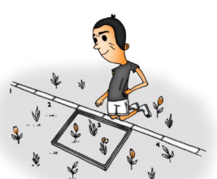

Why did the scientist use this method rather than the random sampling technique? (2)
Transect method will show if there are any differences in individual plant cover/density across the field.
Differences may occur due to variations in the environment across the field.

- Trophic levels in an ecosystem (biology only)

- The food chain below shows the biomass available at each trophic level.

cabbages cabbage white caterpillars sparrows fleas
8445g 775g 85g 2g

- Calculate the efficiency of biomass transferred from the caterpillars to the sparrows. (2)
85/775 x100 = 10.96% (accept 11%)
- Describe three reasons why the efficiency of biomass transfer is not higher between the caterpillars and sparrows. (3)
Three from:
Loss through respiration
Excretion
Egestion
Movement
Not all ingested/absorbed

- Draw an accurate pyramid of biomass on the graph paper using the information from the table below. (3)
Trophic level | % Biomass available
1 | 100
2 | 10
3 | 2
4 | 1
Bars same height
Shape correct
Suitable scale chosen
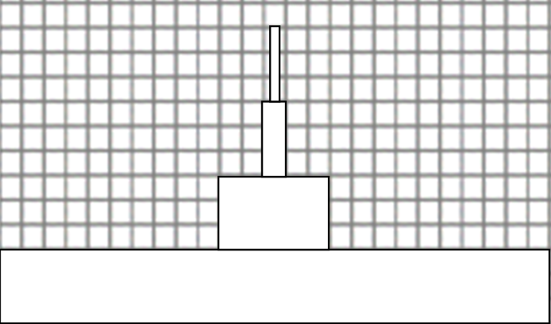
X
X

- Place an X on the trophic level which represents the secondary consumer on the diagram above. (1) see diagram

- Decomposers could be described as the final trophic level in each food chain. Explain how a microscopic decomposer receives its nutrition. (3)
decomposers break down dead plant and animal matter
by secreting enzymes into the environment
small soluble food molecules diffuse into the micro organism

E: Biodiversity and the effect on the human interaction on ecosystems

- The concentration of carbon dioxide in the atmosphere is thought to be changing as the human population increases. The graph shows the atmospheric carbon dioxide levels which were measured at one particular location over time. Similar readings have been recorded in different places around the world.

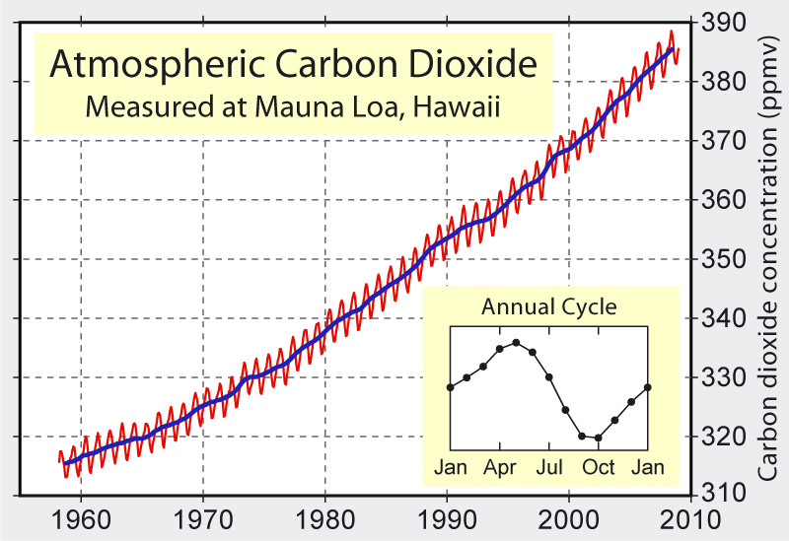

- What is the main trend shown from 1960 to 2010? (1) The amount of carbon dioxide in the atmosphere is increasing
- Calculate the increase in mean carbon dioxide concentration between 1970 and 2000. (3)
Reads off correct value for 1970 mean carbon dioxide concentration
(accept a figure between 367 and 369 ppmv)

Reads off correct value for 2000 mean carbon dioxide concentration
(accept a figure of 324-326ppmv)

Calculates the difference by subtracting 1970 figure from 2000 figure (use figures from above)
e.g. 368- 325 = 43 carbon dioxide concentration ppmv.

To gain full 3 marks, the units ppmv must be stated after the correct answer.

- Suggest why the carbon dioxide concentration changes during the year? (2)

Two from:
In winter more fuel is being burned for heating so more carbon dioxide in the atmosphere.
Less photosynthesis occurring in the winter months as less leaves on tree so less carbon dioxide is removed from the atmosphere by photosynthesis.
Or vice versa for summer months.

- Scientists discovered evidence of an extinct plant by analysing peat layers in a waterlogged Scottish bog. They found pollen in layers that were over 600 years old.
Suggest why the pollen was so well preserved. (2)
Anaerobic conditions/lack of oxygen in the peat bog
prevent decay occurring

- Farming can decrease the biodiversity of an area. Explain how this can occur and suggest what can be done to improve the situation. (4)
Two relevant statements which both explain how the practice reduces biodiversity AND what could be done to reduce the impact.

Use of pesticides and herbicides will reduce biodiversity by killing animals or plants which the farmer does not want eating the crop. Use of GM crops which require less chemicals to be added. Protection of rare habitats by fencing them off.

Growing one crop over a large expanse of land – reintroduce hedges or natural boundaries to fields to enable wildlife to survive. Grow several crops in an area.

Use of fertiliser- run off into waterways can pollute the water and kill animals or plants which rely on the water. Use less artificial fertiliser and more natural fertiliser, reduce the amount that is applied so run off is more controlled.

F: Food production (biology only)

- Mrs Smith keeps 100 chickens to sell their eggs at the local market. Her chickens are free range.
She sells 6 eggs for £2.10.
Mrs Jones also keeps 100 chickens to sell their eggs at the market. She keeps her chickens in cages in a shed. She sells 6 eggs for £1.75.
- Suggest why Mrs Jones can sell her eggs more cheaply than Mrs Smith. (3)
Three linked statements from:
Chickens can’t move around freely so there is less wasted energy being transferred for movement
More energy is being transferred into egg production
More eggs are produced per day
Shed provides a warmer environment so less wasted energy being transferred for temperature regulation by chickens and more available for egg production
Chickens are closer together and so reduce heat loss from their bodies
- Mrs Jones uses chicken feed which is high in protein and low in fibre. Explain how this helps increase the efficiency of biomass transfer. (2)
Protein is required for growth so the higher the food content the faster the chicken will grow.
Low fibre means less energy is transferred to digest the food

- India is a country which is growing economically yet there is still widespread poverty and hunger.
India has one of the largest areas of cultivated land used for food production in the world. In 2012, India was the world’s largest producer of milk, pulses and spices but also had over 30% of its rural population living in poverty. The human population of India continues to increase year on year.

The table below shows the quantity of foods exported from India in mega tonnes (MT)
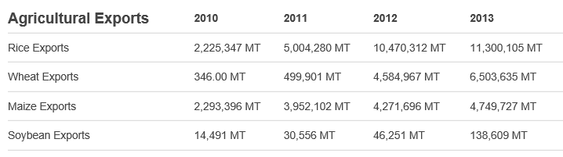
(Information taken from www.foodsecurityportal.org/india)

- Calculate the increase in soybean exports from 2010 to 2013. Express the answer as a percentage. (2)
2010 = 14 491MT
2013= 138 609 MT
Increase is 138 609 – 14 491 = 124 118 MT (1 mark)

124 118 / 14 491 x100 = 856.5% increase in soybean exports (2 marks)

- Suggest reasons why India exports food rather than using it to feed people who are starving in India. (2)
Two linked statements
Get a higher price from another country so helps the economy
Use the extra money for buying agricultural inputs/more seed
People in India don’t want to eat soybean

Extended response question
- A genetically modified plant called short-duration rice has been developed. These plants produce smaller grains of rice in higher yields in 100 days. Unmodified plants take 130 days to produce a crop of larger rice grains but in smaller amounts.
Suggest why this GM crop could improve food security in countries like India. (6)
Level 3 (5-6 marks)
Several varied and coherent explanations are given which logically link food security with short duration rice.
Level 2 (3-4 marks)
A number of relevant points made linking food security and short grain rice usually in a logical sequence
Level 1 (1-2 marks)
Some relevant points made regarding food security or short grain rice with no logical structure.

Biology content (or any other reasonable suggestions which link to food security)
Can produce more rice in a shorter time so can sustain food availability.
Higher yielding plants mean the land is being used as efficiently as possible for food production.
Can grow more than one crop a year so increasing amount of food available in a year.
Could export some rice because more is produced and keep the rest for local use.
Money from the exports could buy new seed/machinery/animals.
If one crop fails due to pests/pathogens/poor climate conditions there is time to sow another crop in the year and increase chance of producing food for the population.
The increasing birth rate means the country needs to produce more food per year with the same amount of land. Short duration rice enables this to happen.

G: Material cycles, decay and indicator species

Extended Response question

- Explain how carbon is cycled in the natural environment. (6)

- Level 3 (5-6 marks)
A detailed and coherent explanation is given which logically links the processes of photosynthesis, respiration, digestion, combustion and decay with explanations of how carbon is cycled.
- Level 2 (3-4 marks)
A number of relevant points made linking processes and the cycling of carbon naturally usually in a logical sequence
- Level 1 (1-2 marks)
Some relevant points made regarding the cycling of carbon in nature with no logical structure.

Biology Content
Photosynthesis removes carbon dioxide from the atmosphere
to make glucose which contains carbon.
Some of this carbon will be converted into plant biomass and fixed.
Plant and animal respiration release carbon dioxide into the atmosphere from glucose.
Animals eat and digest plants which contain carbon compounds and convert this into biomass.
Decomposers secrete enzymes into the environment and cause dead plant and animal material to decompose. This releases carbon dioxide into the atmosphere.
Decomposers respire releasing carbon dioxide into the atmosphere.
Combustion of fossil fuels/peat releases carbon dioxide into the atmosphere.

Extended response question (biology only)
- Design an experiment to investigate the effect of temperature on the growth of mould on bread. Include an equipment list, method and risk assessment in the answer. (6)
- Level 3 (5-6 marks)
A logical plan that INCLUDES most equipment that will allow the effect of temperature on the growth of bread mould to be investigated AND describes how to do this correctly AND includes an appropriate risk assessment.
- Level 2 (3-4 marks)
A plan that INCLUDES some equipment that will allow the effect of temperature on the growth of bread mould to be investigated AND describes how to do this with most steps in the correct order AND includes an appropriate risk assessment.
Level 1 (1-2 marks)
Simple plan that lists some equipment that will allow will allow the effect of temperature on the growth of bread mould to be investigated OR describes how to do this with most steps in the correct order AND includes a simple risk assessment.

- (Biology HT) Indicator species can be used to show the levels of water pollution.
Evaluate the advantages and disadvantages of using the presence of a species such as the rat tailed maggot which is found in polluted water to measure pollution levels in a river. (5)

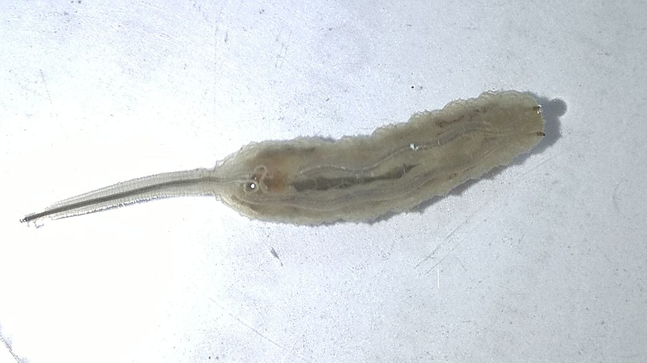

Advantages of using the rat tailed maggot : (2)
It is only found naturally in highly polluted water so if it is present, pollution is present.
You can count the number of indicator organisms in a given area to roughly compare one sample with another.
It is cheap and easy to do. No specialist equipment is needed.

Disadvantages (2)
It does not tell you how polluted the area is accurately.
If the rat tailed maggot is absent this might be for another reason e.g. being eaten by something and this could be interpreted wrongly.

Conclusions: it would be better to use non living indicators such as oxygen or other chemical tests. (1)

